**Hatchery**

**Masters:**

**Add New Cold Room**

To Add a New Cold Room

1. Click on "New Cold Room".
2. You have to enter the value for "Cold Room Name".  
   **Eg :** Suppose the Cold Room Name is "AC Room1" you have to enter *AC Room1* for "Cold Room Name".
3. Once filled click "SAVE" button to Save the Cold Room or click "CANCEL" button to exit without Saving the Cold Room.

**Add New Hatchery No.**

To Add a New Hatchery No.

1. Click on "New Hatchery No.".
2. You have to enter the value for "Hatchery No.".  
   **Eg :**Suppose the Hatchery No. is "H1" you have to enter *H1* for "Hatchery No.".
3. Once filled click "SAVE" button to Save the Hatchery No. or click "CANCEL" button to exit without Saving the Hatchery No.

**Transactions:**

**Add New Tray Setting**

To Add a New Tray Setting

1. You have to select "hatchery".
2. You have to select "Breeder" or "Purchases".

**Eg :** Suppose if you purchased eggs then you have to select Purchases, if you transferred eggs from breeder to hatchery then you have to select Breeder.

1. You have to select "Unit", "Shed" and "Flock".
2. Now enter values for "No of Eggs Set", "Second Set", "Reject", "Waste", "Expected Chicks" and "Loading Time".
3. Now select values for "Loaded By" and "Setting Date".  
   As and when the value for Setting Date is selected the values of Hatch Date will be displayed automatically.

**Eg :** Suppose if the Unit is "SH", Shed is "L1", Flock is "L1-S54", No of Eggs Set is "2000", Loading Time is "2PM", Loaded By "Rajesh" and Setting Date is "1st Jul, 2011" then   
You have to select SH for "Unit", L1 for "Shed", L1-S54 for "Flock".  
Now enter 2000 for "No Of Eggs Set", 14:00 for "Loading Time".  
Now select Rajesh for "Loaded By" and 01.07.2011 for "Setting Date". Hatch Date will be displayed automatically as 22.07.2011 when you select 01.07.2011 for Setting Date.

1. Once filled click on 'SAVE' the Tray Setting Details button to save and 'CANCEL' to exit without saving the Tray Setting Details.

**Add New Hatch Record**

To Add a New Hatch Record

1. Select value for Setting No.
2. Select the Values for Code and enter values Eggs(Rejected) until all the rejection details are filled.
3. Enter Values for DIH, Culls and Avg. Chick Weight.   
   **Eg :** Suppose Setting No. is "SD1", Dead IN Shell(with code EG103) is "53", Infertile(with code EG104) Culls is "62", DIH is "45", Culls is "50" and Avg. Chick weight is "42" then   
   You have to select *SD1* for "Setting No", *EG103* for "Code", *53* for "Eggs", *EG104* for "Code", *62* for "Eggs", *45* for "DIH", *50* for "Culls" and *42* for "Avg. Chick weight".  
     
   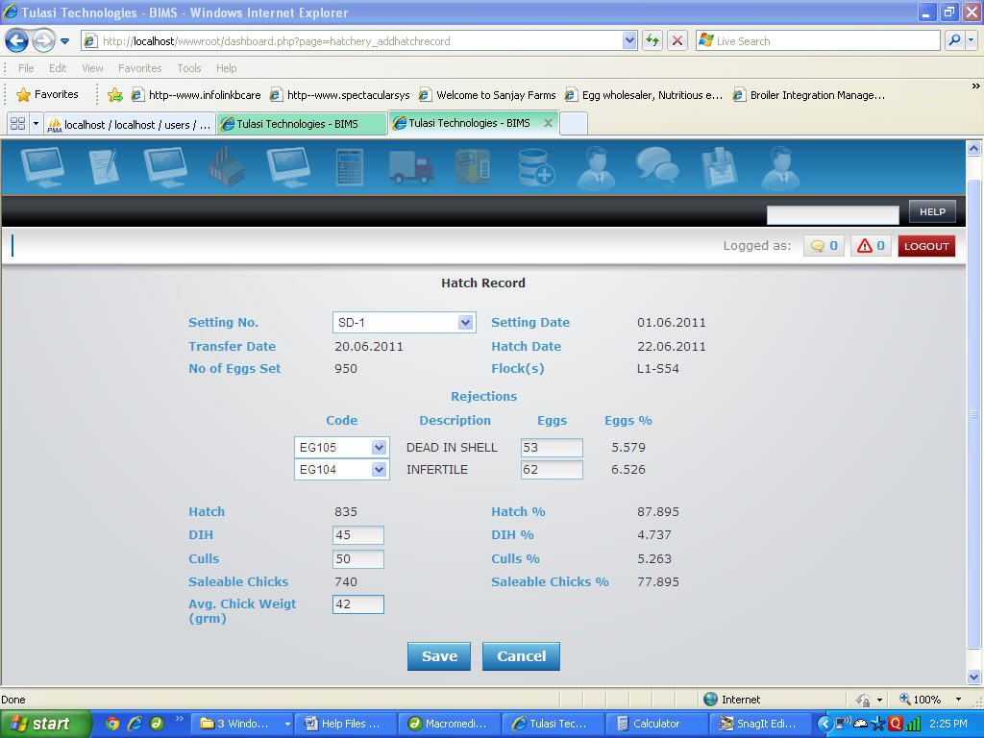
4. Now Click on "Save" button to save the Hatch Record or "Cancel" to exit with out saving the Hatch Record.

**Processing:**

**Add New Vaccination Details**

To Add a New Vaccination Details

1. Select Date of Vaccination, Done By(employee name), Vaccine Code, Enter No. of Chicks and Dosages.   
   **Eg :**Suppose Vaccination Date is "23 June,2011", Done By "K.Ehiga", No.of Chicks is "740", Vaccination Code is "VAC147" and Dosages "700" then   
   You have to select *23.06.2011* for "Date of Vaccination", *K.Ehiga* for "Done By", *VAC147* for "Vaccination Code", enter *740* for "No. of Chicks" and *700* for "Dosages".
2. 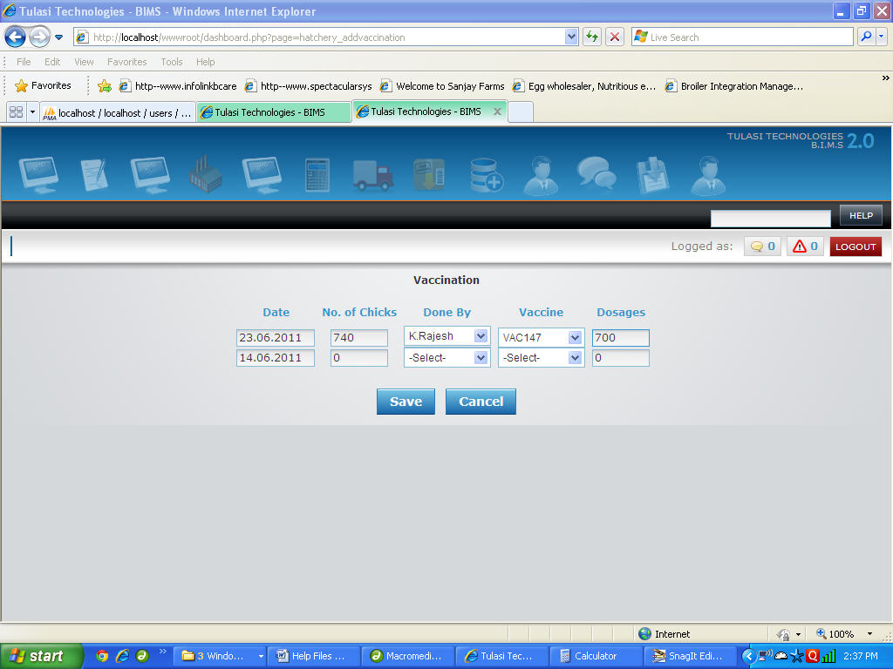
3. Now Click on "Save" button to save the Vaccination or "Cancel" to exit with out saving the Vaccination.

**Add New Chicks Transfer Details**

To Add a New Chicks Transfer Details

1. Select the values for Date, From Hatchery Unit, Farm, Parent Flock, enter values for Flock, No. of Chicks, Price, Free Chicks, DC#, T.Cost(Transportation Cost), Vehicle No., select Driver, T. Mort(Transportation/Box Mortality), Shortage and Remarks.   
   **Eg :** Suppose to transfer 740 chicks to Farm Healthy Farm from Parent Flock "L1-S54" to Flock 1 with price of 20, DC# is 3192, vehicle number KA14 C 0763, driver "Ehiga" and T.Mort of 23 then   
   You have to select *23.06.2011* for "Date", *Hatchery* for "From Hatchery Unit", *Healthy Farm* for "Farm", *L1-S54* for "Parent Flock", enter *1* for "Flock", *740* for "No. of Chicks", *20* for "Price", *3192* for "DC#", *23* for "T. Mort.", *KA14 C 0763* for "Vehicle Number and select *Ehiga* for "Driver".   
     
   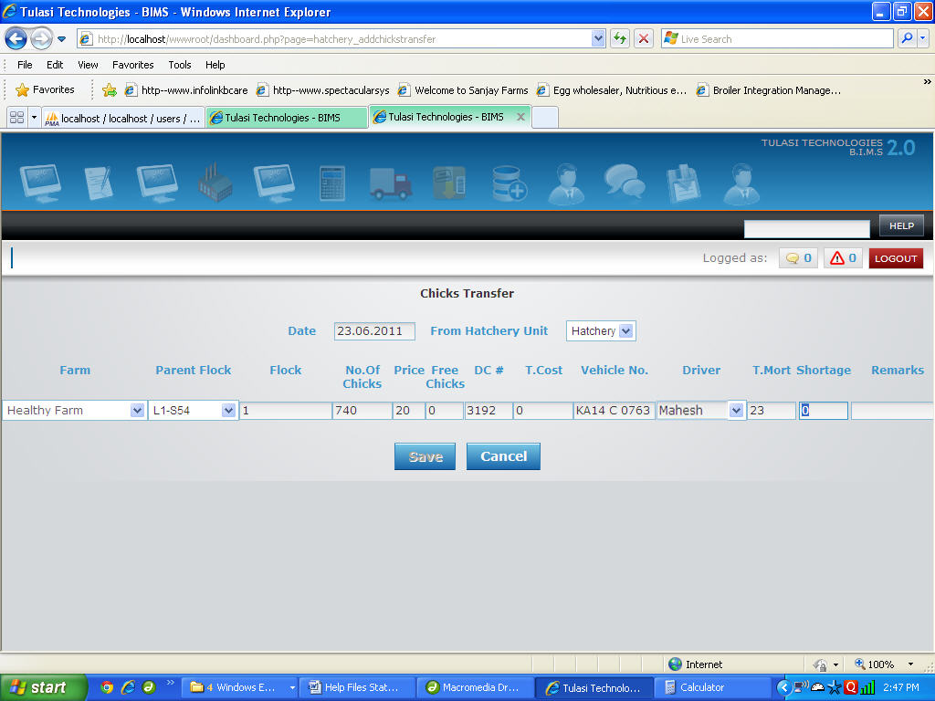
2. Repeat this process until all the transfer details are filled
3. Now Click on "Save" button to save the Chicks Transfer or "Cancel" to exit with out saving the Chicks Transfer.

**Edit Existing Chicks Transfer Details**

To Edit an existing Chicks Transfer Details

1. Select the values for Date, From Hatchery Unit, Farm, Parent Flock, enter values for Flock, No. of Chicks, Price, Free Chicks, DC#, T.Cost(Transportation Cost), Vehicle No., select Driver, T. Mort(Transportation/Box Mortality), Shortage and Remarks if you want any changes from previous values.   
   **Eg :** Suppose if you want to change the DC# from "3000" to "3192" and vehicle number from "KA34 C 1236" to "KA14 C 0763" then   
   You have to enter *3192* for "DC#" and *KA14 C 0763* for "Vehicle Number.   
     
   
2. Repeat this process until all the transfer details are filled
3. Now Click on "Save" button to save changes to the selected Chicks Transfer or "Cancel" to exit with out saving the changes to the selected Chicks Transfer.

**Edit existing Vaccination Details**

To edit an existing Vaccination Details

1. Select Date of Vaccination, Done By(employee name), Vaccine Code, Enter No. of Chicks and Dosages if you want any changes from previously selected values.   
   **Eg :**Suppose if you want to change the Vaccination Date from "21 June, 2011" to "23 June,2011" and Dosages from "750" to "700" then   
   You have to select *23.06.2011* for "Date of Vaccination“ and *700* for "Dosages".   
   
2. Now Click on "Save" button to save the changes to the selected Vaccination or "Cancel" to exit with out saving the changes to the selected Vaccination.